Web Network Load Balancer (WNLB)
Software Requirements Specification

Version 1.0



Supervisor Name: Mr. Tanweer Arshad
Student Name: Faheemullah Memon
Student ID: MC070402736

Revision History

Date (dd/mm/yyyy) | Version | Description | Author
22/11/2012 | 0.1 | Initial draft | Mc070402736
25/11/2012 | 1.0 | Finished and reviewed | Mc070402736

Table of Contents
Revision History 2
1. Introduction 4
1.1 About this document 4
1.2 The Project 4
1.2 Project Scope 5
1.3 Deliverables 5
1.4 Timelines 6
1.5 Implementation limitations 6
2. Functional and Non-Functional Requirements: 7
2.1 Functional Requirements 7
2.1.1. Configuration wizard 7
2.1.2. Intercept and off-load incoming requests to available least busy servers 7
2.1.3. Provide a web-based configuration and monitoring interface 7
2.1.4. Health checking and failover 7
2.1.5. Logging 8
2.1.6. Diagnostics / Crash Collection 8
2.1.7. Session stickiness 8
2.2. Non-functional requirements 8
2.2.1. Robustness 8
2.2.2. Scalability 9
2.2.3. Security 9
2.2.4. Performance 9
2.2.5. Usability 9
3. Use Case Diagram(s): 10
3.1. Basic Use Case 10
3.1.1. Diagram 10
3.1.2 Description 10
3.2. Extended Use Case 11
3.2.1. Diagram 11
3.2.2. Description 11
3.3. System Configuration 12
3.3.1 Diagram 12
3.3.2. Description 12

1. Introduction

1.1 About this document

This is a software requirements specification document for project Load Balancing of Network Traffic. The document goes over the software requirements from high-level to detailed user interaction scenarios.

1.2 The Project

In 1989, Sir Tim Berners-Lee, a British scientist wrote a proposal regarding a way of sharing information with the help of cross-referenced documents spread across the world accessible via internet, which eventually came to be known as World Wide Web. World Wide Web (or called the web for short) took off and quickly became a viable way of information sharing. Information was first shared in form of text and pictures, sound and video soon followed. A set of documents, called web pages, written in a simple markup language, HyperText Markup Language (HTML), delivered these resources to the interested audience. These web pages were stored on a machine dubbed web server and were made available on Internet with help of grand network hardware infrastructure and series of networking protocols, predominantly TCP/IP and HTTP. The person who wanted to access this information used client software called web-browser.

As the web became more and more accessible, more information was being shared. This put a strain on both network infrastructure and web servers. The network infrastructure not scaled out for the given volume of data traffic resulted in limited network bandwidth and slower Internet connection or less accessibility. Web pages that contained multi-media elements were slower to load and respond. Still today and in even for foreseeable future Web servers remain in mode of constant hardware and software upgrades.

Although network bandwidth problem is dependent on hardware used in the network infrastructure, web servers can respond faster with help of specialized load balancing software programs. This project is a network load balancer that supports asymmetric clustering model. In a typical asymmetric model one entity is considered pivot or master that distributes traffic load across the connected slave entities.

1.2 Project Scope

As described in latter section, in face of ever increasing web traffic network load balancers are inevitable. This project takes on challenge of implementing a web based network load balancer using .NET technologies, specifically ASP.NET. It will run on top of Internet Information Server, a web server implementation from Microsoft Corp. It will work as a smart conduit and distribute incoming requests among configured web servers to balance the load across server cluster. Stating broadly, it will follow asymmetric model for load balancing. At a higher level it will support following core functions:

- Accept HTTP based web requests from users and route them to configured resource servers
- Handle potentially large volume of web traffic
- Provide network monitoring and reporting services for system administrators
- Provide failover support and automatically remove defective servers from pool
- Support session affinity/stickiness for subsequent user requests to allow proper session management.

1.3 Deliverables

This software project and related documentation will be submitted for final project, a requirement for completing Master of Information Technology (MIT) degree at Virtual University of Pakistan. All documents, source code, and binaries will be owned and distributed according to guidelines of Virtual University of Pakistan. This project will contain following artifacts.

- Software Requirements documents
- Software architecture and design documents
- Source codes - .NET and IIS compatible
- Executable binaries

1.4 Timelines

Complete software application along with documentation will be developed in the period specified by Virtual University and which is normally in a year’s time. Deliverables will be produced and submitted as directed by supervisor.

1.5 Implementation limitations

When it comes to network load balancing, software can easily get very complicated and there are slew of expectations from such software. A lot of associated functionality doesn’t fall directly under load balancing but is normally combined in one package, like caching and content delivery network services. These services lie beyond scope of this project. Similarly, more complicated functions of load balancers like DDoS protection require more resources both time and material and so also fall beyond the scope of this project. However, our software will implement core components of a network load balancer as suggested in project scope. For an example following features will not be supported:

- HTTP Caching
- DDoS protection
- TCP/IP based offloading
- TCP buffering

2. Functional and Non-Functional Requirements:

2.1 Functional Requirements

2.1.1. Web-based Configuration and Monitoring interface

System configuration should be available via a web interface to enable remote administration. Interface will be password protected. It will allow users to do following set of operations.

      - User authentication and authorization
      - Allow admin to change password for the system
      - Create and update system configuration. System configuration includes adding, updating, and deleting servers in the pool.
      - Adding, updating, and removing guest applications in the system.
      - Monitor status of current network configuration. Check server status, activity, and traffic information.
      - Present detailed traffic reports

2.1.2. Intercept and off-load incoming requests to backend servers

System will intercept all incoming web requests for the cluster. It will run on top of Microsoft Internet Information Server and face the incoming traffic. It will off-load incoming traffic to available servers based on selected routing algorithm. It will keep track of activity on individual servers.

2.1.3. Session stickiness

System will provide an option to turn on or off the session stickiness feature. This is an essential feature for dynamic applications that use sessions to keep track of user interaction for multiple HTTP requests. With this option enabled users will be directed to same slave server for subsequent requests. Other high level frameworks on slave machines will handle session management.

2.1.4. Database Storage

System will store all entered configuration and user information in to a permanent database. This will ensure that all settings are preserved in case system goes down and comes back up.

2.2. Non-functional requirements

2.2.1. Robustness

Since this is going to be a critical piece of software it should be a very important feature of this software to maintain certain level or robustness and fault tolerance. At the very basic level it should provide fail-over support. If a slave server fails down it should be removed from the pool and subsequent requests will not be forwarded towards it. System should report selected system administrator of the failure via email messages. In case all the servers were down system will provide a friendly message to the end users and support graceful failure strategy.

2.2.2. Scalability

Scalability is an essential aspect of this system. It will allow system admin to add slave servers to the system as desired. The number of slave server will be limited mostly by the hardware limitations. Core footprint of the system will be very little depending on the configuration settings done.

2.2.3. Security

System will support security options provided by HTTP protocol. It will allow SSL and TLS based message transmission encryption. It will support all SASL authentication mechanisms for user authentication.

2.2.4. Performance

Sole purpose of this software is to achieve better performance by load balancing. System will be efficient in routing requests and increase performance for subsequent requests from the users.

2.2.5. Usability

A rather un-friendlier side of the system software is that they are hard to use, configure, and diagnose. This system will handle these problems and take a user-friendly approach to usage, configuration and diagnostics. System configuration wizard, GUI based error-reporting system, remote system administration will be some of the features that help with usability of the system.

3. Use Case Diagram(s):

3.1. Basic Use Case

3.1.1. Diagram
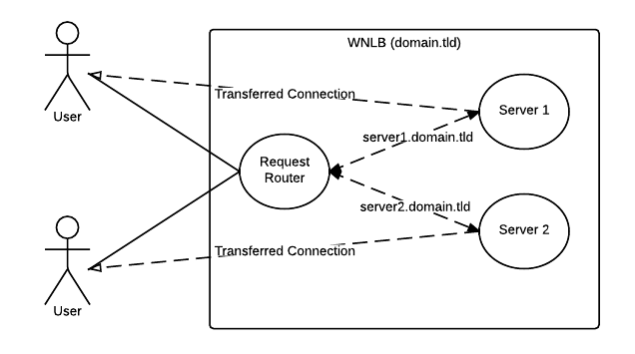
Figure 1

3.1.2 Description

The diagram demonstrate very high-level requirement of the system. When a user sends the request to the load balancer, it redirects the call to available server. Available server responds to the user with desired resources. After the basic selection and depending on system configuration, subsequent requests will be direct between user and the resource server. This diagram also shows session stickiness concept.

3.2. Extended Use Case

3.2.1. Diagram
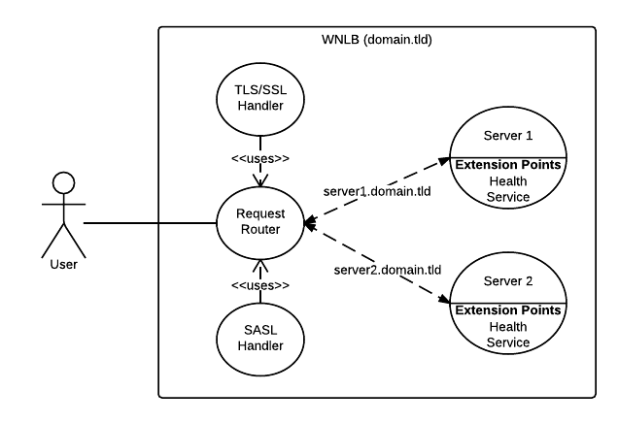Figure 2

3.2.2. Description

This diagram shows session-less approach. Every request passes through the request router and is secured behind a certificate and an authentication mechanism. There is a part of the resource server that represents the health service, which report system stats and health data back to the server.

3.3. System Configuration

3.3.1 Diagram
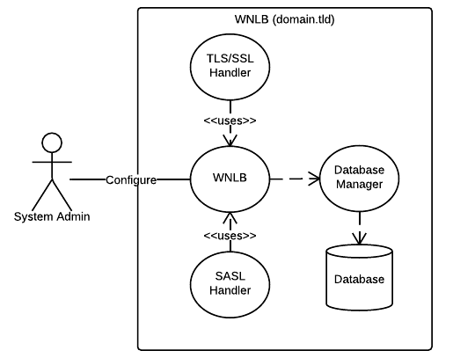
Figure 3

3.3.2. Description

This is a basic diagram showing system admin user changing system configuration. System configuration will be saved in permanent storage. Storage can be database or an XML configuration file depending on available options.
4. Usage Scenarios:

Use Case Title | Configuration Console Authentication
Abbreviated Title | Login
Use Case Id | 01
Requirement Id | 2.1.1.1.
Description: When accessing web-based configuration console, system will present a login screen for user authentication and demand a valid username and password. System will bar users from entering system with incorrect username and password information.
Pre Conditions:
- System is installed and setup correctly on the server
- System is accessible from IIS on user machine and there are no Firewall or other network connectivity issues.
- System admin opens up the browser and enters the software URL in browser of choice.
Task Sequence |  | Exceptions
- System admin enters the URL in the browser and password page loads up |  | Software not installed properly or wrong URL entered. An error page shows up with relevant diagnostics information.
- Admin enters the username and password and clicks the “Login” button. |  | Error shows if username or passwords are empty or incorrect.
- System logs user in and loads the dashboard. |  | In case of incorrect user name or password, system will present an error.
Post Conditions:
- System will be ready to take user requests and distribute amongst the slave machines.
- System will be ready for remote administration
Unresolved issues:
Authority: Administrator
Modification history:
Author:
Description:

Use Case Title | Allow admin to change password for the system
Abbreviated Title | Change Password
Use Case Id | 02
Requirement Id | 2.1.1.2
Description: Authenticated admin users will have an option to change or update login password.

Pre Conditions:
- System was configured previously and admin logs in successfully in the system.
Task Sequence |  | Exceptions
- System admin enters the URL in the browser and login page loads up |  | Software not installed properly or wrong URL entered. An error page shows up with relevant diagnostics information.
- Admin enters the pre-set password and hits a login button. |  | System shows error in case of wrong password entered.
- Admin is taken to the home page of system. On home page there will be a link to load the change password form.
- Admin will load change password form and enter current, new, and confirm password information to change the password. System will notify admin if password changed successfully. |  | System will not change password if previous password as incorrect or new password doesn’t meet minimum size limit of 6 characters.
Post Conditions:
Unresolved issues:
Authority: Administrator
Modification history:
Author:
Description:

Use Case Title | Add Backend Server
Abbreviated Title | Add Backend Server
Use Case Id | 03
Requirement Id | 2.1.1.3.
Description: System will allow authenticated admins to add new server into the pool by filling out the required information form.

Pre Conditions:
- Admin has access to the machine.
- Backend servers are available on the network
Task Sequence |  | Exceptions
- System admin logs into the web console and system dashboard is loaded. |  | Software not installed properly or wrong URL entered. An error page shows up with relevant diagnostics information.
- Admin selects the option to add new server as provided on the dashboard. |  | System will present correct validation in cause if incorrect information is filled out.
- System loads a form to fill out server information like hostname or internet address and http service port.
- System loads the newly added server on the dashboard and starts sending traffic towards the new server.
Post Conditions:
- System will send traffic only if newly added server is accessible on the network.
Unresolved issues:
Authority: Administrator
Modification history:
Author:
Description:

Use Case Title | Update backend server
Abbreviated Title | Update backend server
Use Case Id | 04
Requirement Id | 2.1.1.3.
Description: Admin will be able to change name, address, or port of any server as required.

Pre Conditions:
- System was configured previously and admin has access to the machine.
- Backend server record exists in the system
Task Sequence |  | Exceptions
- On system dashboard, admin will be able to select edit or updated action against any server in the pool.
- System will load edit/update form with information of the selected server and allow editing of the fields.
- Admin will be able to save any changes made to the server current configuration. |  | System will provide proper validation for user errors.
- Admin will have an option to cancel the operation.
- Changes to the record will be applied to the system immediately and new traffic will be redirected accordingly.
Post Conditions:
- Backend server is available and accessible on the network.
Unresolved issues:
Authority: Administrator
Modification history:
Author:
Description:

Use Case Title | Delete backend server
Abbreviated Title | Delete Server
Use Case Id | 05
Requirement Id | 2.1.1.3.
Description: System admin will be able to delete a backend server using web console.
Pre Conditions:
- System was configured previously and admin has access to the machine.
- The server in question is added to the system previously.
Task Sequence |  | Exceptions
- On system dashboard, admin will be able to select delete action against any server in the pool.
- Admin will select the delete option and a confirmation form will be presented.
- System will delete the server and stop any traffic flow immediately.
- Admin will also have an option to cancel the deletion operation on confirmation form
Post Conditions:
Unresolved issues:
Authority: Administrator
Modification history:
Author:
Description:

Use Case Title | List Server Pool
Abbreviated Title | Backend Server Listing
Use Case Id | 06
Requirement Id | 2.1.1.3. and 2.1.1.5.
Description: System will present a list of server added to the pool. System will also show preview of server status, traffic flow, server activity, and uptime reports.
Pre Conditions:
- System was configured previously and admin has access to the machine.
- There are backend server instance added and available.
Task Sequence |  | Exceptions
- System will present list of servers available in the pool on dashboard to authenticated admin user.
- System will also provide live stats of these servers like: Status, Activity, Uptime, and Traffic Hits
Post Conditions:
Unresolved issues:
Authority: Administrator
Modification history:
Author:
Description:

Use Case Title | Add Application
Abbreviated Title | Add Application
Use Case Id | 07
Requirement Id | 2.1.1.4.
Description: System will allow authenticated admin user to add guest application to the system. System will give admin option to select routing algorithm and servers from the pool.
Pre-Conditions:
- System was configured previously and admin has access to the machine.
- There are backend server instance added and available.
Task Sequence |  | Exceptions
- System will present an option to add application for admin users.
- System will present a form to collection application details and preferred algorithm and back end servers.
- Admin will submit the form with valid entries and system will start routing traffic on added path immediately |  | System will provide data validation to deter user errors.
- On application information form, system will allow users to select one of following routing algorithm:
  - Round Robin
  - Weighted
  - IP Hash
  - Cookie Based
Post Conditions:
- If any of the server from server pools available, system will start routing new traffic on app path immediately.
Unresolved issues:
Authority: Administrator
Modification history:
Author:
Description:

Use Case Title | Edit Application
Abbreviated Title | Edit Application
Use Case Id | 08
Requirement Id | 2.1.1.4.
Description: System will allow authenticated admin user to change existing application settings.
Pre-Conditions:
- System was configured previously and admin has access to the machine.
- There are backend server instance added and available.
- There is an application record in the system.
Task Sequence |  | Exceptions
- System will present an option against an application to edit or update.
- System will be presented with a form to manipulate information after selecting the edit option.
- Admin will be able to save or discard changes based on preference. |  | System will provide data validation to deter user errors.
- System will start routing traffic with updated settings immediately.
Post Conditions:
- If any of the server from server pools available, system will start routing new traffic on app path immediately.
Unresolved issues:
Authority: Administrator
Modification history:
Author:
Description:

Use Case Title | Delete Application
Abbreviated Title | Delete Application
Use Case Id | 09
Requirement Id | 2.1.1.4.
Description: System will allow authenticated admin user to change delete application settings.
Pre-Conditions:
- System was configured previously and admin has access to the machine.
- There are backend server instance added and available.
- There is an application record in the system.
Task Sequence |  | Exceptions
- System will present an option against an application to delete.
- System will be presented with a confirmation screen after selecting the delete option.
- Admin will be able to save or discard changes based on preference.
- System will stop routing traffic to deleted application path immediately.
Post Conditions:
Unresolved issues:
Authority: Administrator
Modification history:
Author:
Description:

Use Case Title | List Applications
Abbreviated Title | List Applications
Use Case Id | 10
Requirement Id | 2.1.1.4.
Description: System will list available guest applications and allow browsing.
Pre-Conditions:
- System was configured previously and admin has access to the machine.
- There are backend server instance added and available.
- There is an application record in the system.
Task Sequence |  | Exceptions
- System will show list of available applications to the logged in user.
- System will provide a browse option against each application record for admin users. The link will take admin users to the external address of the guest application.
Post Conditions:
Unresolved issues:
Authority: Administrator
Modification history:
Author:
Description:

Use Case Title | Server Traffic Graphs
Abbreviated Title | Detailed Traffic Report
Use Case Id | 11
Requirement Id | 2.1.1.6.
Description: System will collect and report minute-wise, hourly, daily, and weekly traffic details in graphical form
Pre-Conditions:
- System was configured previously and admin has access to the machine.
- There are backend server instance added and available.
- There is an application record in the system.
Task Sequence |  | Exceptions
- System will provide a link on home page for admin user to navigate to the traffic details page
- When selected, system will present minute wise, hourly, daily, and weekly traffic report for every server in the pool.
Post Conditions:
Unresolved issues:
Authority: Administrator
Modification history:
Author:
Description:

Use Case Title | Request Routing
Abbreviated Title | Routing
Use Case Id | 12
Requirement Id | 2.1.2.
Description: A user tries to access the web application from the load-balancing cluster and is served the required content from configured back-end server at that given point.
Pre Conditions:
- System was configured previously and the web application is installed on the slave servers in the cluster.
Task Sequence |  | Exceptions
- User enters the URL of master machine from browser of choice. |  | Software not installed properly or wrong URL entered. An error page shows up with relevant diagnostics information.
- Web server intercept the call, checks the state of slave servers and re-directs the client to configured backend server
- Slave server gets the request and serves the client.
- If target slave server is down, then traffic re-routed to another available server seamlessly. Former server is taken out of the pool temporarily.
Post Conditions:
1. User gets to content desired faster
Unresolved issues:
Authority: NONE
Modification history:
Author:
Description:

Use Case Title | Request Routing with Session Stickiness
Abbreviated Title | Routing Sessions
Use Case Id | 13
Requirement Id | 2.1.3.
Description: A user tries to access the session based web application from the load-balancing cluster and is redirected to the slave server that already holds the previously established session.
Pre Conditions:
- System was configured previously and the web application is installed on the slave servers in the cluster.
- Session sticky routing algorithm (IP-Hash or Cookie-Based) is selected for the application.
Task Sequence |  | Exceptions
- User enters the URL of master machine from browser of choice. |  | Software not installed properly or wrong URL entered. An error page shows up with relevant diagnostics information.
- Web server intercept the call, checks the session cookie in HTTP Request and re-directs the client to respected slave server |  | In case if there is no cookie, system finds the least busy server and assigns that to the session. Creates a cookie and address to the request for subsequent calls.
- Slave server serves the cookie with established session state.
Post Conditions:
1. User gets to content desired faster and session state is preserved
Unresolved issues:
Authority: NONE
Modification history:
Author:
Description:

Use Case Title | System configuration persistence
Abbreviated Title | System configuration persistence
Use Case Id | 14
Requirement Id | 2.1.4.
Description: System will persist the configuration permanently in a database and service server resets.
Pre-Conditions:
Task Sequence |  | Exceptions
- System will persist entered configuration information throughout sever resets.
Post Conditions:
Unresolved issues:
Authority: NONE
Modification history:
Author:
Description:

